***Spotify database***

***Abstract:***

The Spotify database project aims to design and implement a MySQL-based dataset for a music streaming platform, which stores information about users, artists, songs, podcasts, albums. This project provides a comprehensive database solution to manage and organize music-related data efficiently.

The project focuses on ensuring data integrity, efficient data retrieval, and optimal storage of music-related information. By using primary keys, foreign keys, and appropriate data types, a robust database structure is established to handle a large volume of data and support complex queries efficiently. Indexing and normalization techniques are employed to enhance query performance and reduce redundancy.

***Aim:***

The aim of this project is to design and develop a MySQL-based database system for a music streaming platform. It aims to provide a seamless and user-friendly experience for music lovers to access and enjoy their favorite songs. The database will store and organize information about users, songs, albums, playlists, and tracks, allowing users to search, create playlists, and listen to music effortlessly.

***Introduction:***

In today's digital world, music streaming platforms have gained immense popularity. These platforms provide users with access to an extensive library of songs from various genres and artists. Spotify, one of the leading music streaming platforms, allows users to discover new music, create playlists, and listen to their favorite songs on-demand. This project aims to create a similar platform using MySQL as the database management system.

***Objective:***

The main objective of this project is to develop a digital solution that enables businesses to visualize and manage their various processes using a Spotify ER Diagram. This solution will offer several benefits, including:

1. Process Visualization: The project aims to provide a visually appealing and intuitive interface that represents business processes through a Spotify ER Diagram. This visual representation will help stakeholders easily comprehend and navigate through the complex relationships and interactions of different processes within the organization.

2. Process Optimization: By analyzing the digital representation of business processes, the solution will identify bottlenecks, redundancies, and other areas for improvement. This will empower organizations to streamline their processes, remove inefficiencies, and enhance overall productivity.

3. Collaboration and Communication: The project aims to facilitate seamless collaboration and communication among different teams and individuals involved in the business processes. With the help of the Spotify ER Diagram, stakeholders can easily understand each other's roles, dependencies, and responsibilities, leading to efficient process execution and improved teamwork.

By achieving these objectives, the project seeks to revolutionize how businesses manage their processes, transforming them into streamlined, efficient, and collaborative workflows.

In conclusion, this project aims to develop a comprehensive solution that utilizes a Spotify ER Diagram to visually represent and optimize various business processes. By leveraging the advantages of this digital tool, organizations can streamline their operations, enhance collaboration, and achieve higher productivity.

***E-R diagram:*** 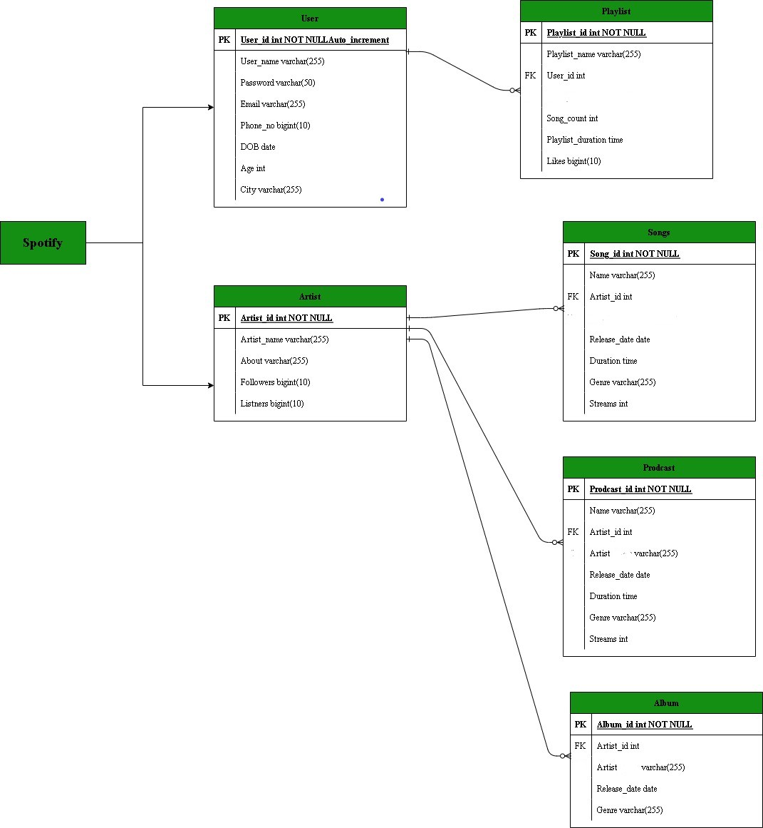

***Structure of table***

***Users:-***

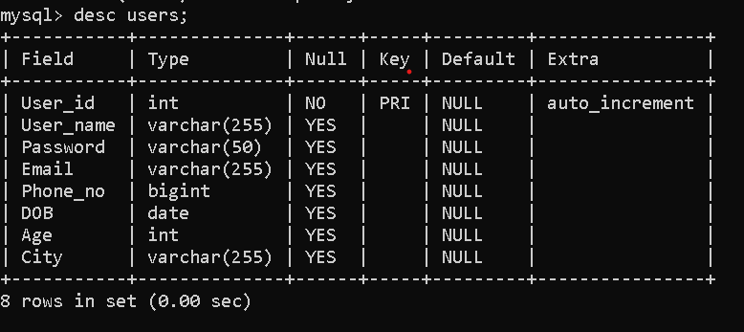

***Artists:-***

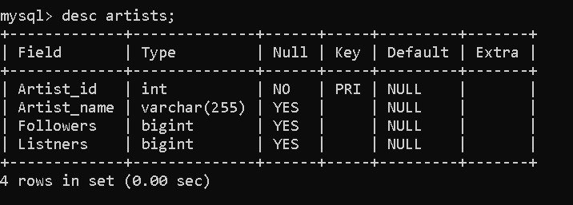

***Playlists:-***

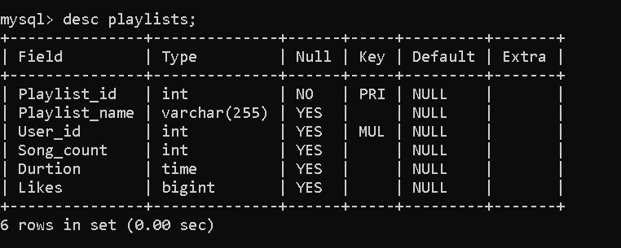

***Songs:-***

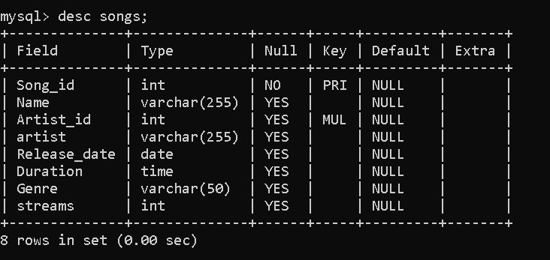

***Podcasts:-***

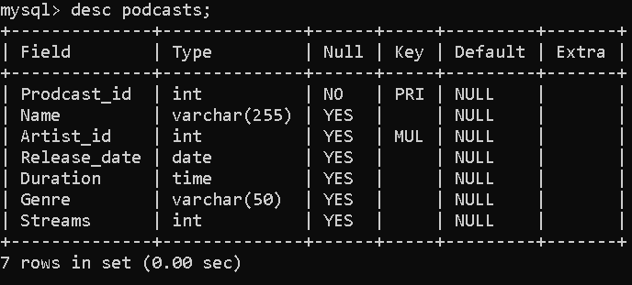

***Albums:-***

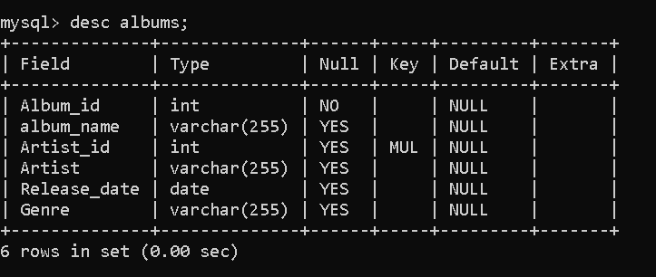

***Contents of table***

***Users:-***

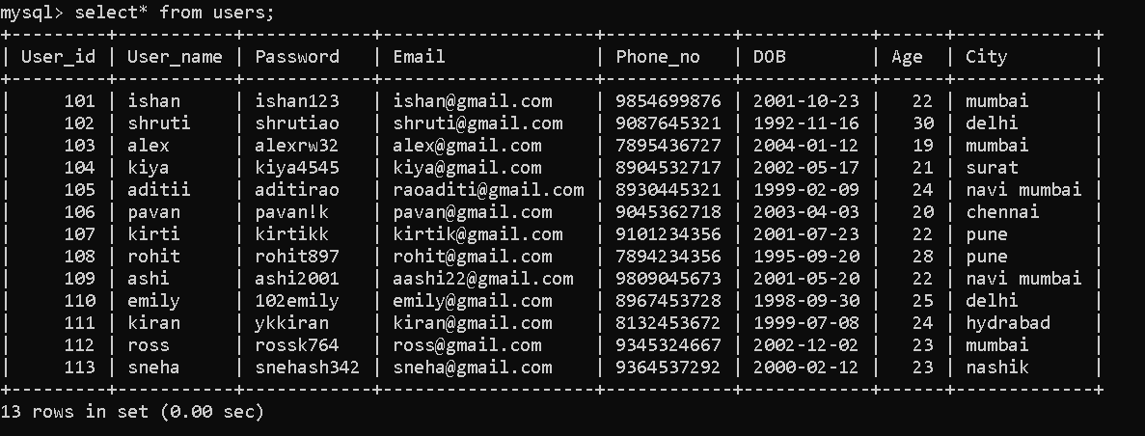

***Artists:-***

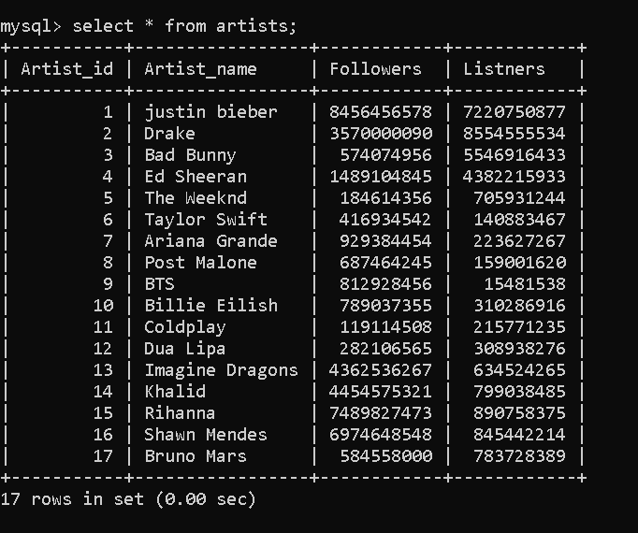

***Playlists:-***

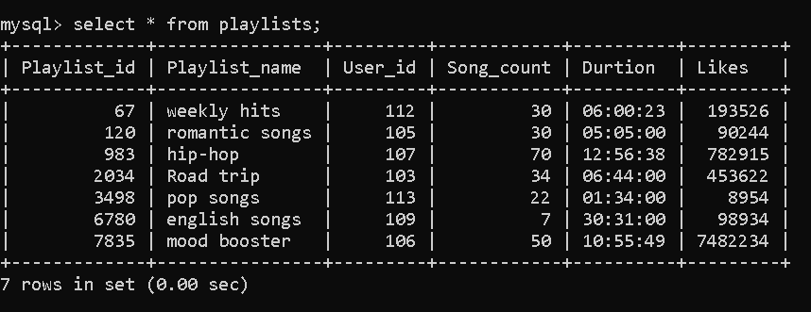

***Songs:-***

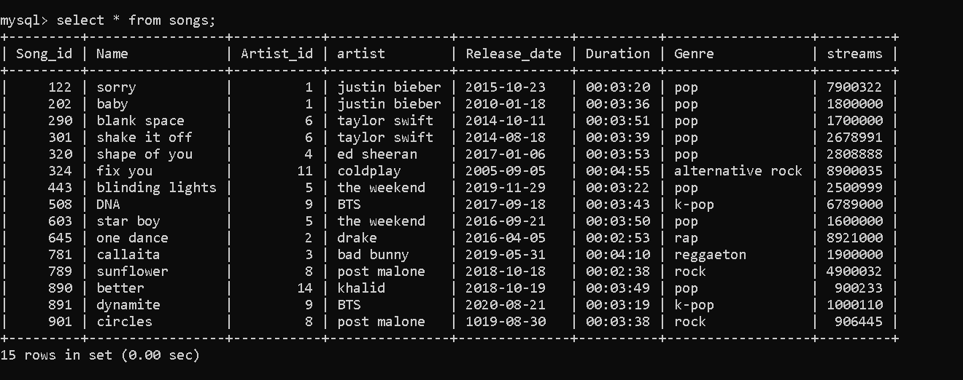

***Podcasts:-***

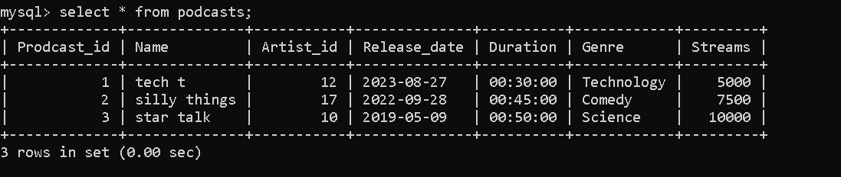

***Albums:-***

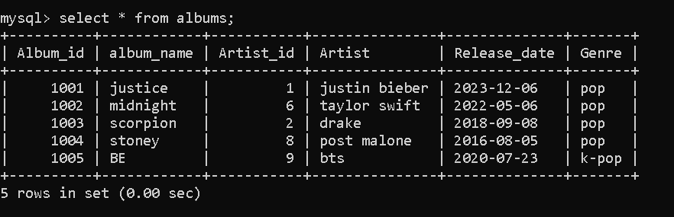

***Queries***

***Update:-***

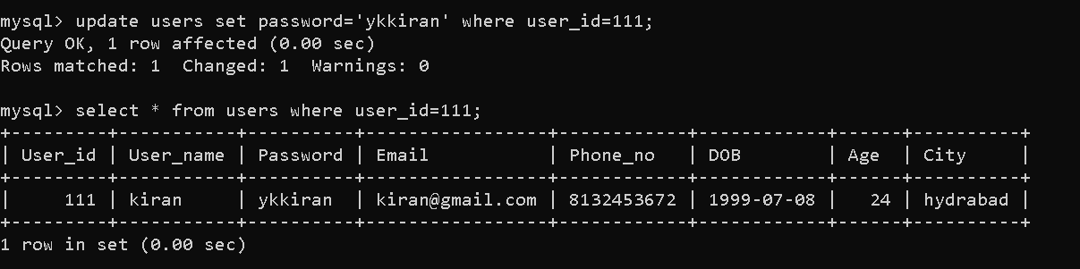

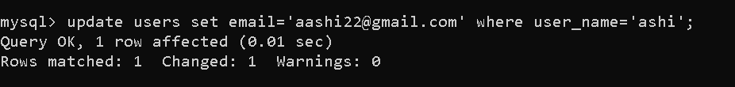

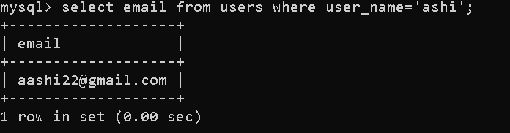

***Create:-*** 

***Functions:-***

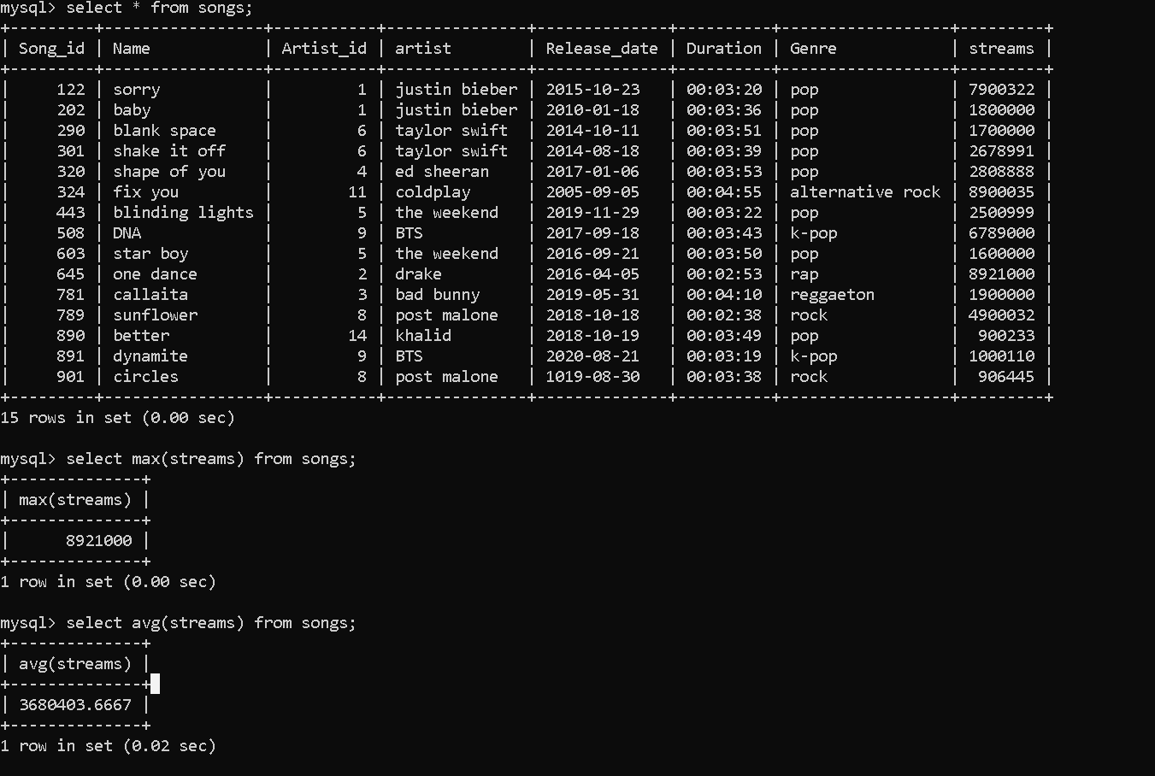

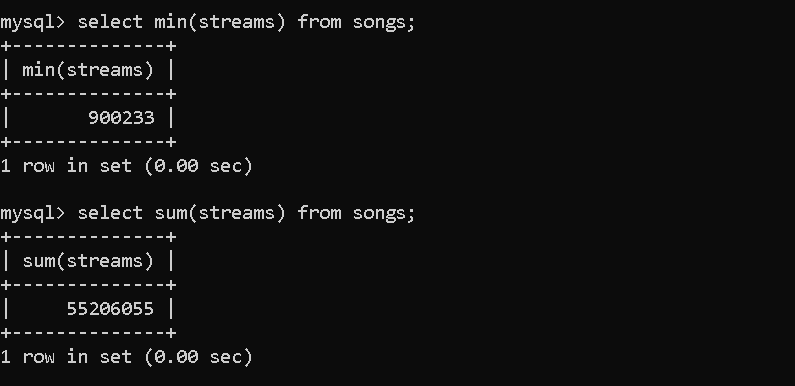

***Oprators:-***

*And:-*

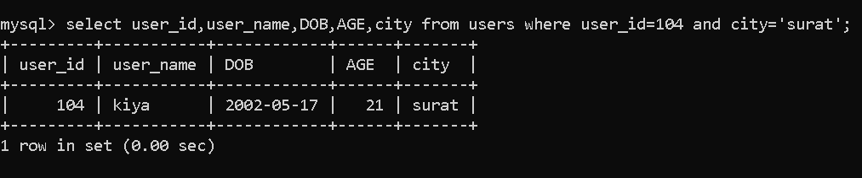

*OR:-*

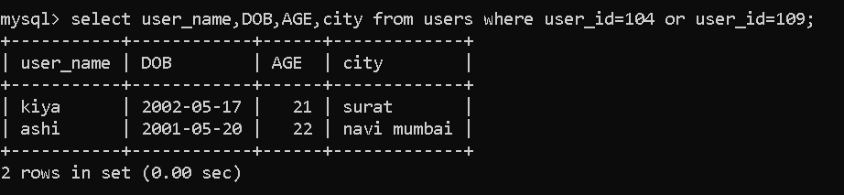

*Not equal to:-*

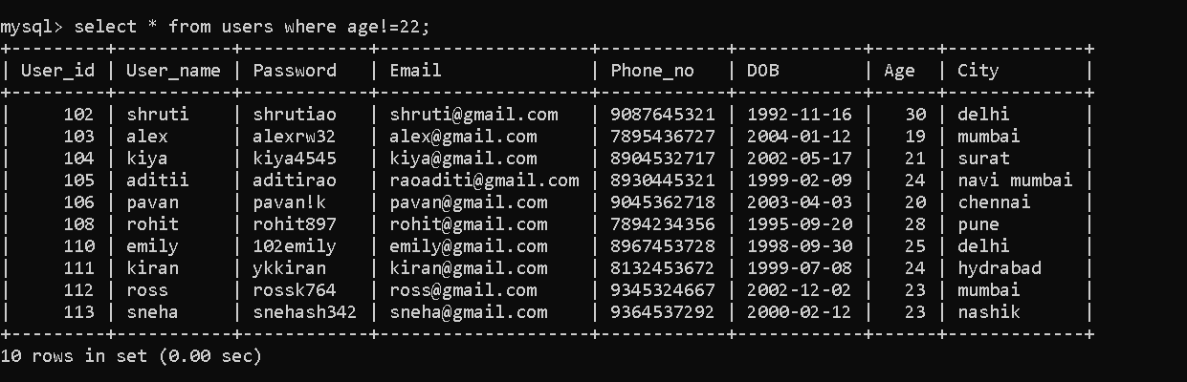

Greater/less than equal to:-

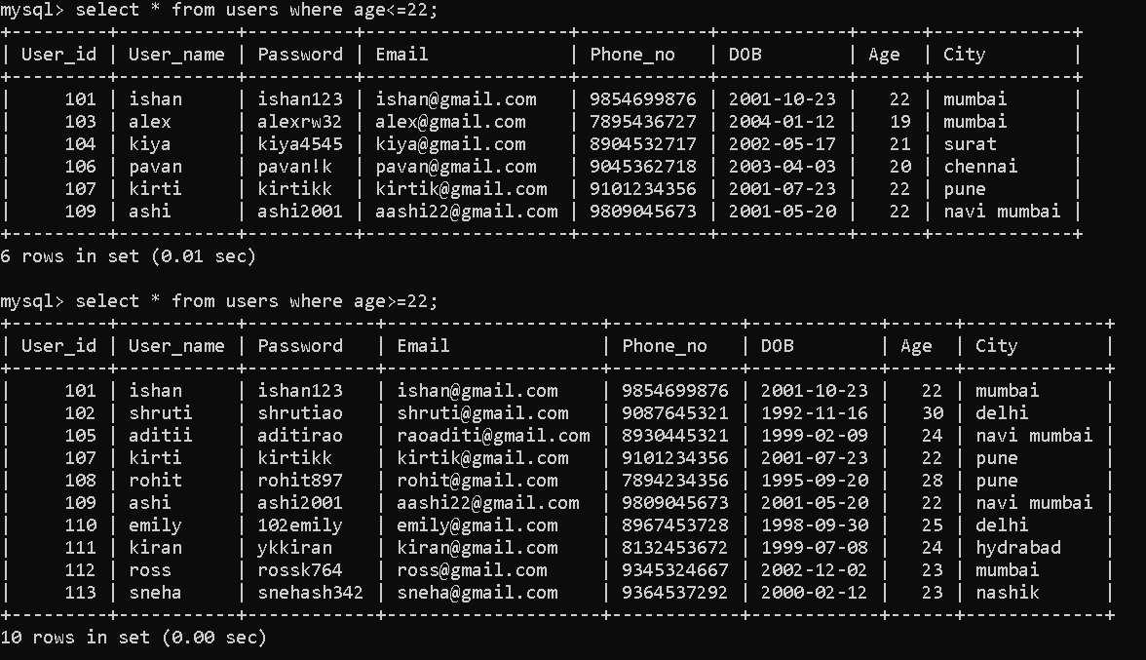

Between:-

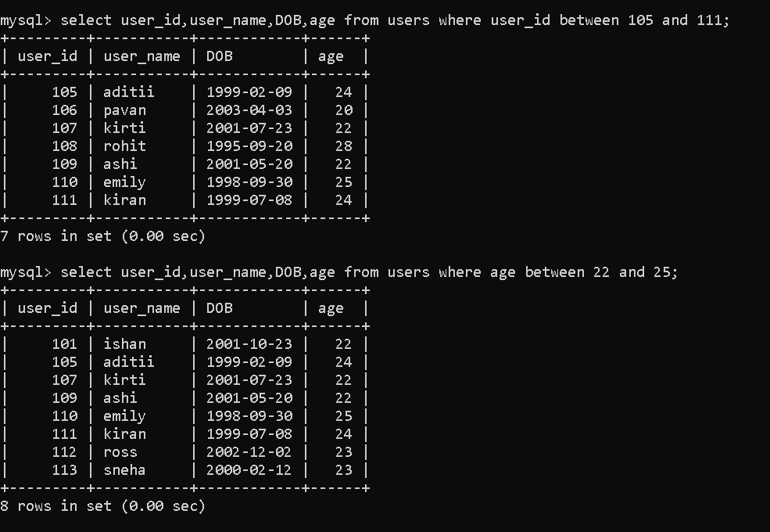

Rlike:-

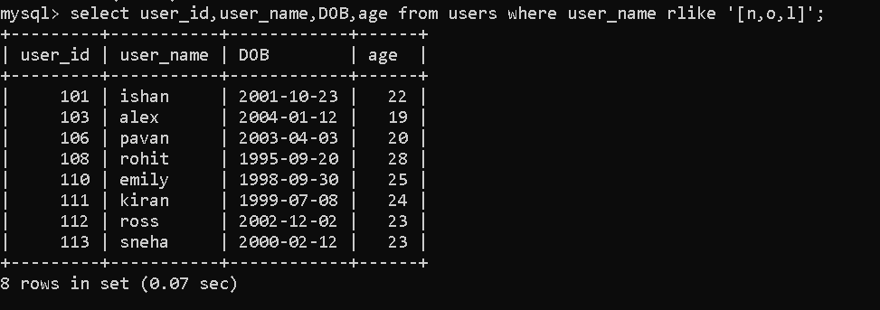

Like:-

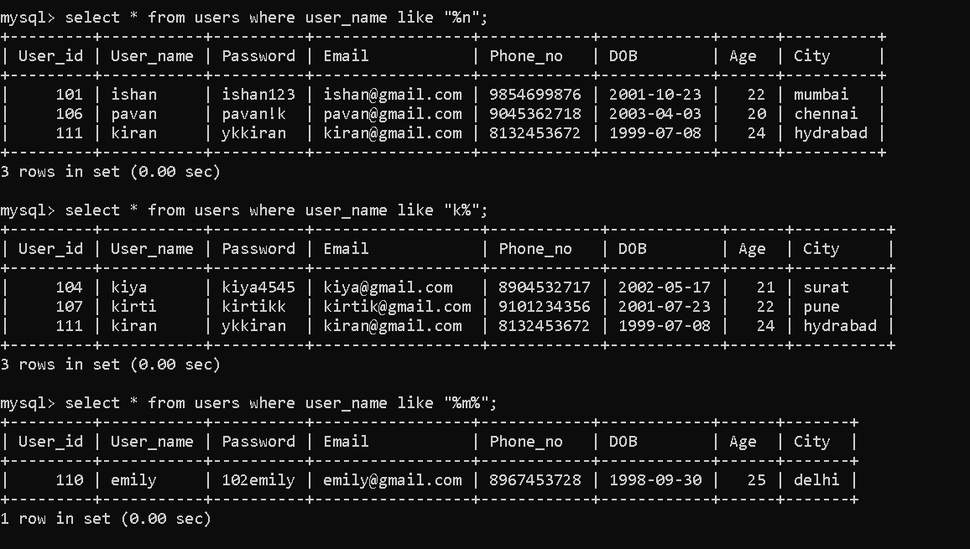

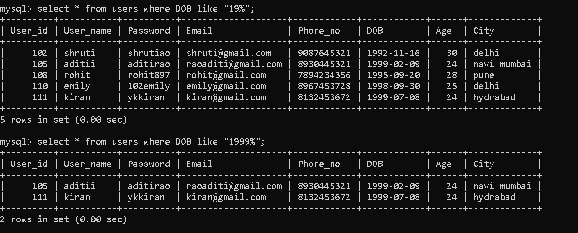

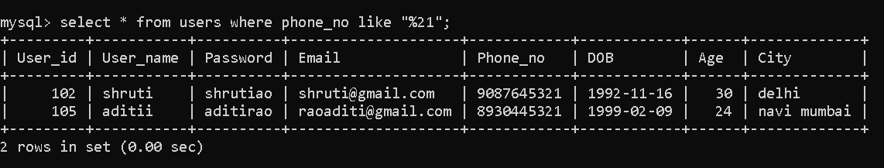

**Clause:-**

Group by:-

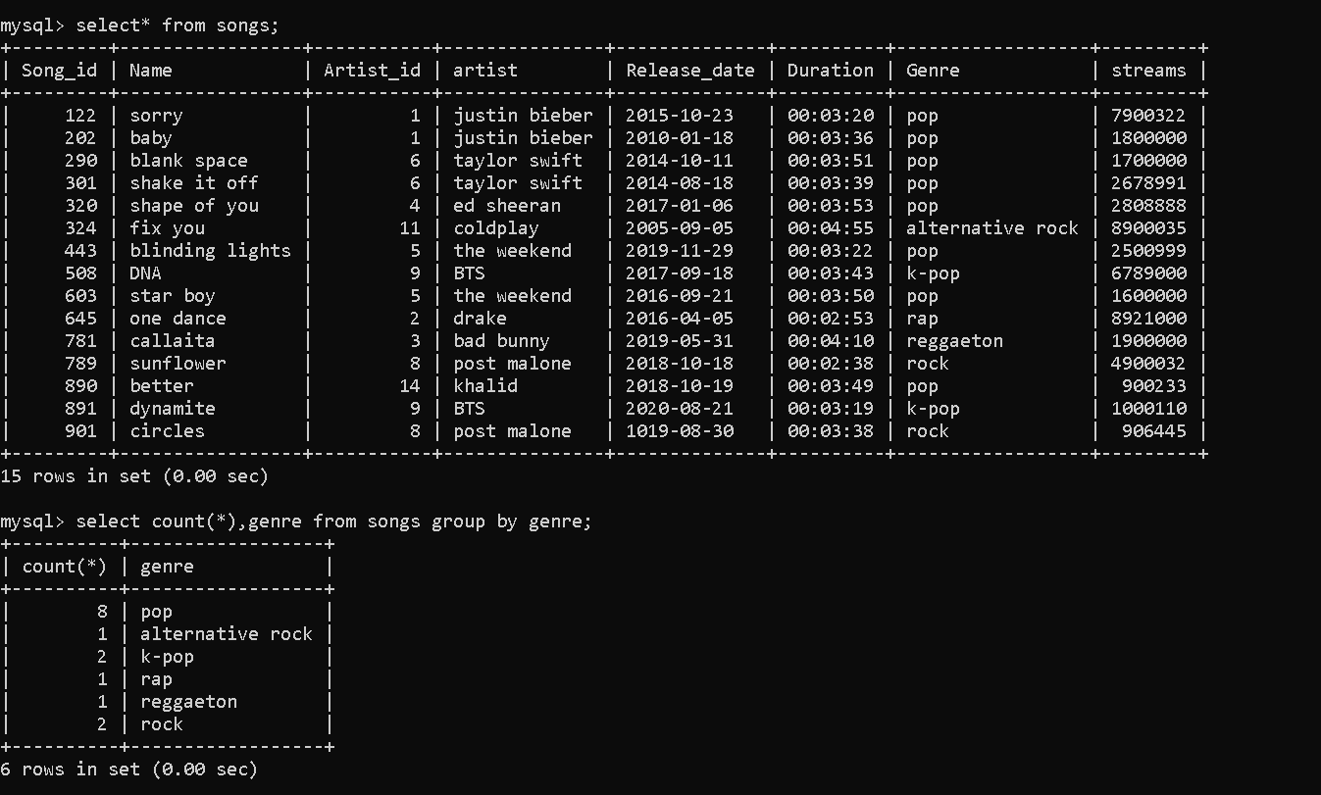

Group by with having:-

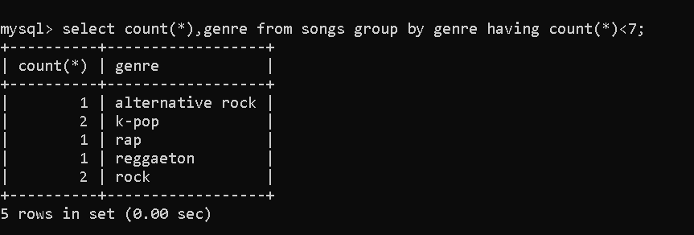

Where:-

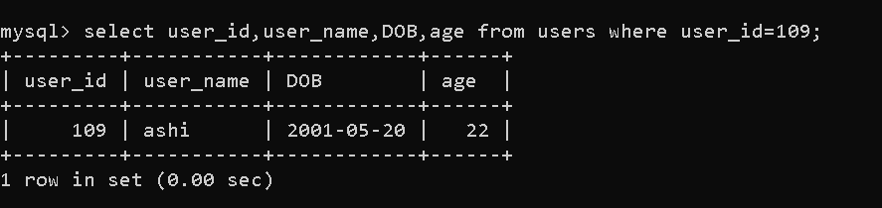

Order by:-

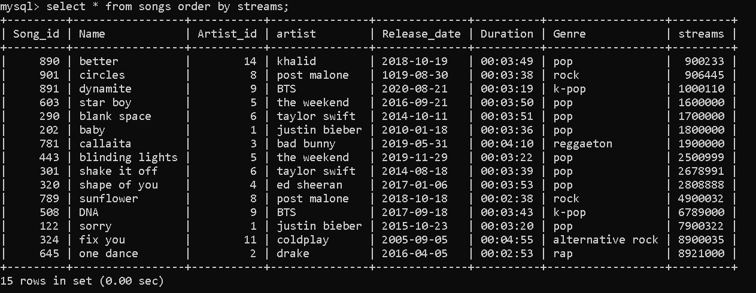

Order by with group by:-

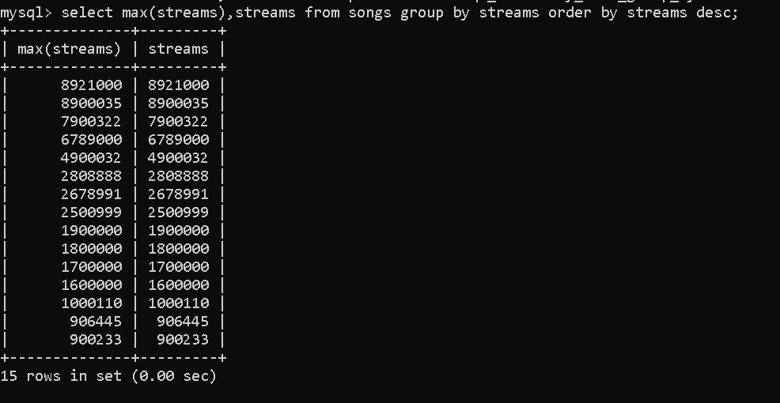

***Subquery:-***

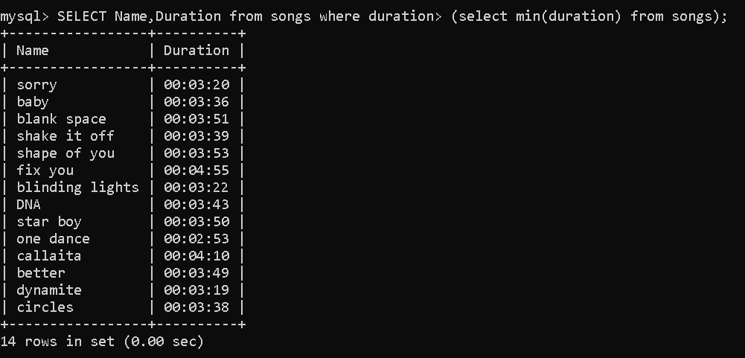

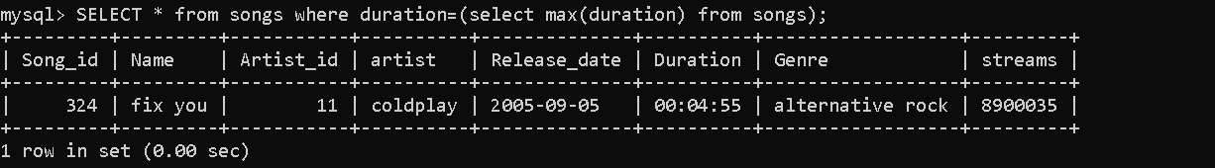

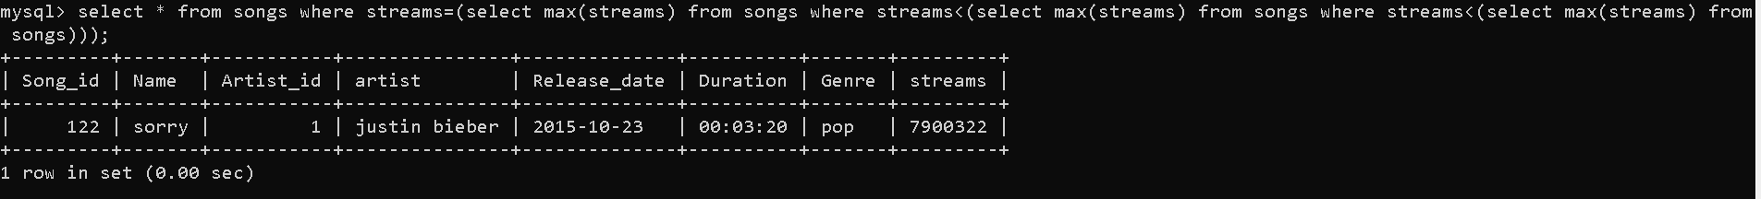

***Joins:-***

Inner join:-

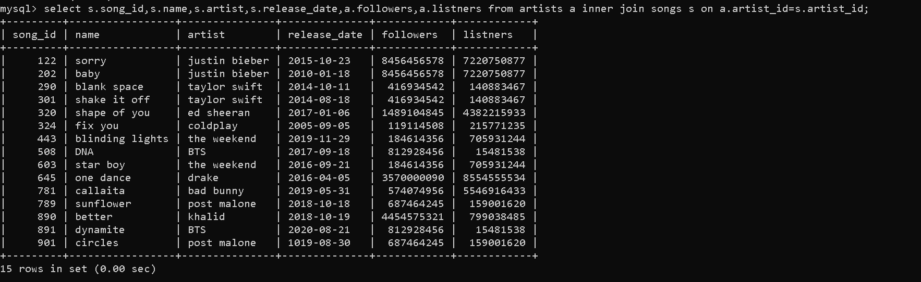

Left join:-

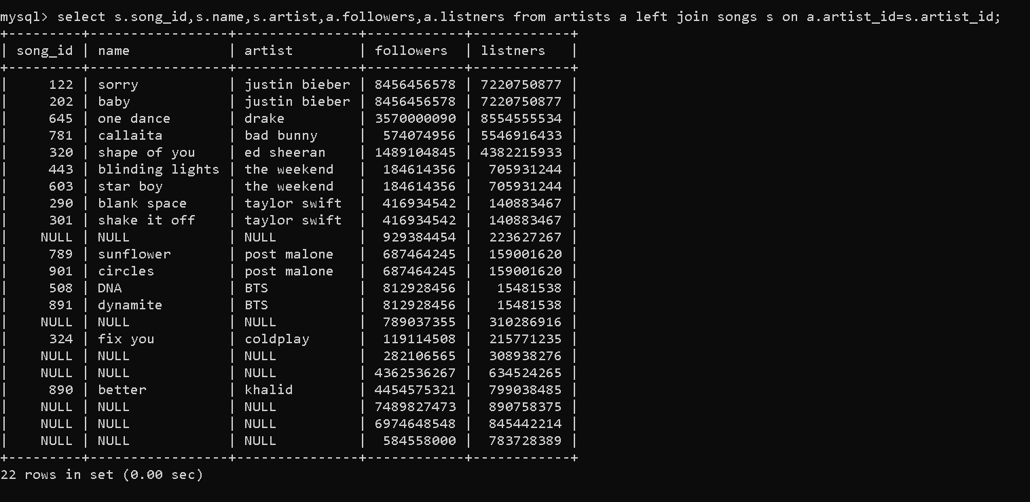

Right join:-

